Conducting a Site Survey for an Interior Design Project: An In-Depth Guide

A site survey involves a thorough examination and documentation of the room or space to be designed. This initial step lays the foundation for the entire design process, providing information about the space that will influence design decisions further down the line. The importance of a site survey cannot be overstated, as it ensures the design is feasible, functional, and tailored to the space's unique characteristics.



Fig. 1. Pixabay (n.d.), A tape measure

# Importance of a Site Survey

The following points define the importance of carrying out a thorough and detailed site survey: Accurate Measurements: Precise dimensions are crucial for planning layouts, selecting furniture, and ensuring everything fits appropriately. Inaccuracies can lead to costly mistakes and delays.

Understanding Spatial Flow: Observing how people move through the space helps in designing functional layouts that enhance the flow and usability of the room.

Identifying Architectural Features and Constraints: Noting the locations of doors, windows, columns, and other architectural elements is vital for integrating these features into the design.

Assessing Natural Light: The amount and direction of natural light influence colour choices, furniture placement, and the need for artificial lighting.

Technical Assessments: Understanding electrical outlets, heating, ventilation, and air conditioning (HVAC) systems, and plumbing is necessary for planning technical aspects of the design.

Client Needs and Preferences: A site survey allows the designer to understand client requirements and how they relate to the existing space.

# Types of Site Survey

A **Dimensional** site survey is the detailed process of measuring and documenting the precise dimensions of a space. This type of survey provides the accurate measurements needed to create detailed floor plans, furniture layouts, and ensure that design elements fit appropriately within the space.

A **Photographic** site survey involves capturing a series of photographs of the space to document its current condition, layout, and features. This type of survey complements the dimensional site survey by providing visual context and aiding in the design process.

For a thorough understanding of a space, combining both dimensional and photographic site surveys is highly effective. The dimensional survey provides the precise measurements needed for planning, while the photographic survey offers visual context and aids in identifying details that might not be apparent in measurements alone. Together, these surveys provide a holistic view of the space, ensuring a well-informed and accurate interior design process.

# Tools Needed for a Site Survey

In order to record all the necessary information and measurements, it is important to make sure that when going on site to conduct a survey, you have with you the appropriate equipment. Below you will find a detailed list of the tools and equipment you will need and what you will need it for.

## Measuring Tools:

Tape Measure: For measuring smaller distances.

Laser Measure: For quick and accurate measurement of larger distances. Measuring Wheel/ Ribbon: For very large spaces.

## Recording Tools:

Notebook and Pen: For taking notes and sketching layouts.

Digital Camera or Smartphone: For capturing images of the space. Tablet or Laptop: For digital note-taking and creating detailed sketches.

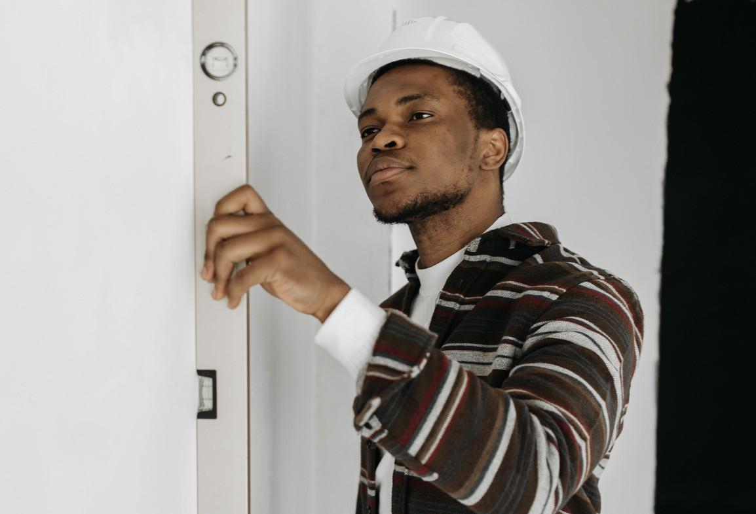

Fig. 2. Canva (n.d.) A man carrying out a site survey

## Software:

Photo Management Software: For organising and annotating photos.

## Other Essentials:

Graph Paper: For hand-drawing floor plans and elevations. Flashlight: To inspect poorly lit areas.

Level: To check the evenness of floors and walls. Tripod for camera stability.

# Detailed Guide to Conducting a Site Survey

This guide will walk you through every step necessary to thoroughly understand the space you are designing, from the interior specifics to the exterior environment and the property's location. As mentioned above, it is important to make sure that you have a solid understanding of the property, its location and measurements.

## Preparation

1. **Gather Tools:**

Measuring Tools: Tape measure, laser measure, measuring wheel/ ribbon. Recording Tools: Notebook, pen, digital camera or smartphone, tablet or laptop. Software: Photo management software.

Other Essentials: Graph paper, flashlight, level.

## Review Existing Documents:

If you have been given these by your client, study any existing floor plans, blueprints, or other relevant documents to better understand the space.

1. **Client Briefing:** (This can also be carried out on the day of the site survey)

Schedule a meeting with the client to discuss their needs, preferences, and objectives for the space.

Gather information on the client's lifestyle, aesthetic preferences, and functional requirements.

**Step-by-Step Site Survey**

1. **DIMENSIONAL SURVEY**
   1. **Exterior and Location Considerations**

**Property Location:**

Neighbourhood Context: Understand the neighbourhood's character, including its style, atmosphere, and cultural or historical significance.

Accessibility: Note the ease of access to the property, parking facilities, and proximity to public transport.

Views: Identify key views from the interior to be highlighted or preserved.

Climate: Consider the local climate, influencing material choices and design elements such as insulation, heating, and cooling.

Orientation: Assess the building's orientation concerning the sun’s path to maximise natural light and energy efficiency.

## Building Exterior:

Architectural Style: Note the architectural style and distinctive features of the building’s exterior.

Condition: Assess the condition of exterior walls, roof, windows, and doors. 

Materials: Identify materials used on the exterior (brick, stone siding, etc.)

Surrounding Environment: Observe the surrounding landscape, including trees, gardens, and external structures that influence interior lighting and views.

Entrances and Exits: Document locations of all entrances and exits.

## Initial Walkthrough

**General Inspection:**

 Walk through the entire space to get a general feel for its dimensions, layout, and condition.

 Take initial notes on any visible features, damages, or areas of interest.

## Detailed Measurement

Floor Plan Layout: Draw a rough sketch of the shape of the room in plan view (i.e. a floor plan)

- Remember, we do not use rulers or any other design equipment to do this. We need to be quick and efficient in this process.

Then:

* + Measure the length, width, and height of each room.
  + Mark the locations of doors, windows, and other openings on the floor plan.
  + Measure the height of windows and doors from the floor.
* Measure the height of windows and doors.
  + Note any changes in ceiling height.

## Architectural Features:

Measure and document built-in features, such as fireplaces, columns, alcoves, and nooks. Record dimensions and locations on the floor plan.

## Technical Elements:

Identify and document the locations of electrical outlets, switches

Document existing light fixtures, including their types, locations, and conditions. Note the presence of radiators, underfloor heating, or air conditioning units.

Note any visible wiring, pipes, or conduits that could impact the design.

## Structural and Condition Assessment

Walls and Ceilings:

Inspect for structural issues such as cracks, damp spots, or uneven surfaces. Note the material and condition of walls and ceilings.

Floors:

Assess the condition and material of the flooring. Use a level to check for uneven areas.

Note any changes in floor levels or transitions between different flooring materials.

## Environmental Factors

Ventilation and Heating:

Document the functionality of any existing HVAC systems (radiators, AC systems, extractor fans etc.).

Identify any drafts or areas with poor ventilation.

Note the style/condition of radiators, underfloor heating, or air conditioning units.

Lighting:

Assess the quality and coverage of artificial lighting.

Note the connection of outlets to switch plates (dimmers, single or double sockets etc.). Observe the direction and intensity of natural light throughout the day.

Note areas that are shaded or receive direct sunlight.

Record window types, sizes, and the presence of any coverings or treatments.

Acoustics:

Assess the acoustics of the room, noting any issues with echo or noise. Identify sources of noise from outside the room or building.

## PHOTOGRAPHIC SURVEY

* 1. **Exterior and Location:**

Take photos of the building’s exterior, including entrances, windows, and landscaping. Document views from the property and the surrounding environment.

## General Overview:

Position yourself in the centre of the wall opposite the wall you need to record, and take a picture of each wall that makes up the room. Include part of the floor, ceiling and corners of the wall. If it doesn’t fit in one image, take two/ three consecutive pictures. Do not use the panoramic option on a camera, as this will skew the shape and size of the room.

Take wide-angle shots of each room to capture the overall layout and flow. Photograph the space from multiple angles to provide a comprehensive view.

## Detailed Shots:

Capture close-up images of architectural features such as mouldings, trims, and built-ins. Document the condition of surfaces like walls, floors, and ceilings.

Photograph technical elements like electrical outlets, switches, and plumbing fixtures.

Once you have completed your Site Survey, it is now time to return to your base and analyse the data you collected. By carefully analysing the information collected during the site survey, interior designers can ensure that their design solutions are both practical and inspired. This process involves verifying measurements, reviewing photographs, synthesising client needs, and planning the project’s feasibility, budget, and timeline. A thorough analysis transforms raw data into a strategic plan, setting the stage for a successful interior design project that is tailored to the space and meets the client’s expectations.

This detailed guide ensures that all relevant factors are considered, leading to more accurate and inspired design solutions. Including an assessment of the building’s exterior and the property's location ensures a holistic approach that integrates the interior design with its broader context, enhancing the overall impact and cohesion of the project.